System Security: Purchase Orders

| August-20 |

**Document Overview**

**Documentation Goals**

This documentation is intended to provide instruction for ***Security within the Purchase Order Programs****.*

**Table of Contents**

**System Admin Program Master for PO** 2

Program Master [NS8] 2

Browse Programs 2

View Programs 3

User Groups 3

**System Admin Program Master for PO Line** 4

Program Master [NS8] 4

Browse Programs 4

View Programs 5

User Groups 5

# **System Admin Program Master for PO**

## Program Master [NS8]

### Browse Programs

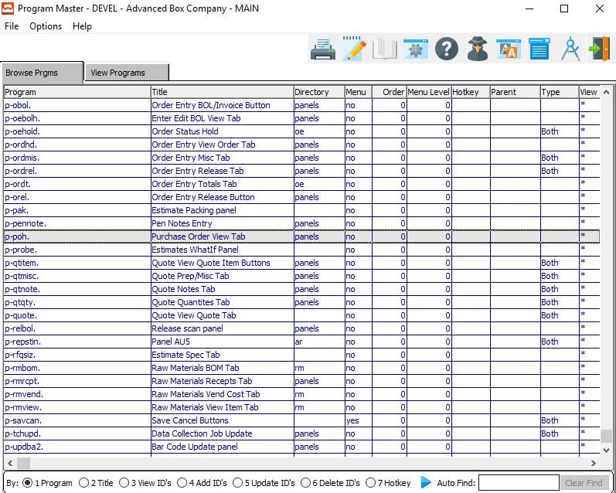

The user can search for their desired program by using the *Auto Find* search box at the bottom of the screen.

Security for *Purchase Order View Tab* can be found within the (p-poh. ) program. This program specifically grants security access to the main information for Purchase Orders. Security for individual PO Lines uses a different program.

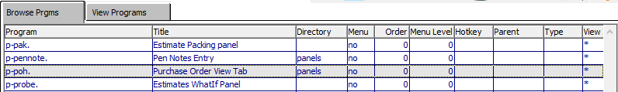

One the system administrator has highlighted their desired program within the list, they may set security by either *User Group* or *User ID* view the *View Programs* tab.

Please Note: *User Groups* are best.

### View Programs

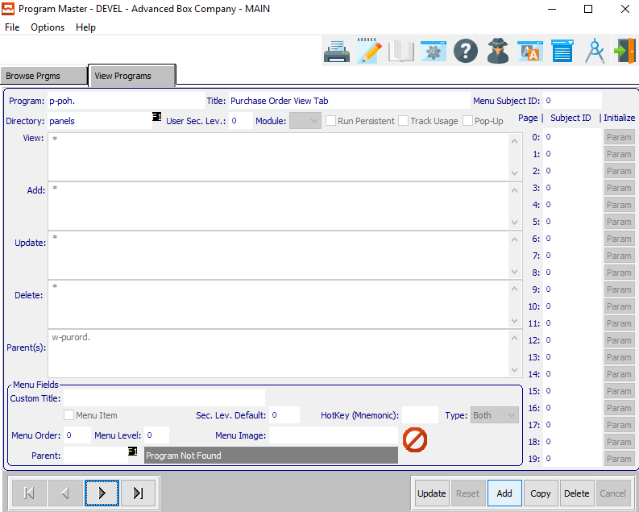

An asterisk (*) within any of these fields means that everyone can access that portion of the program.

#### View ID’s

The *View ID’s* is to set up who can view the data within the currently selected program.

#### Add ID’s

The *Add ID’s* is security for who can add data within the currently selected program.

#### Update ID’s

The *Update ID’s* is security for who can update existing data within the currently selected program.

#### Delete ID’s

The *Delete ID’s* is security for who can delete existing data within the currently selected program.

### User Groups

Under ***“N”-“U”-“5”***, the user can add groups, and assign users to that group. Then, if a user is hired or fired, the system administrator may simply change the users within the group that the employee belongs to. Therefore, no security will need to be changed.

If a user does not have access, the selected button will be grayed out.

# **System Admin Program Master for PO Line**

## Program Master [NS8]

### Browse Programs

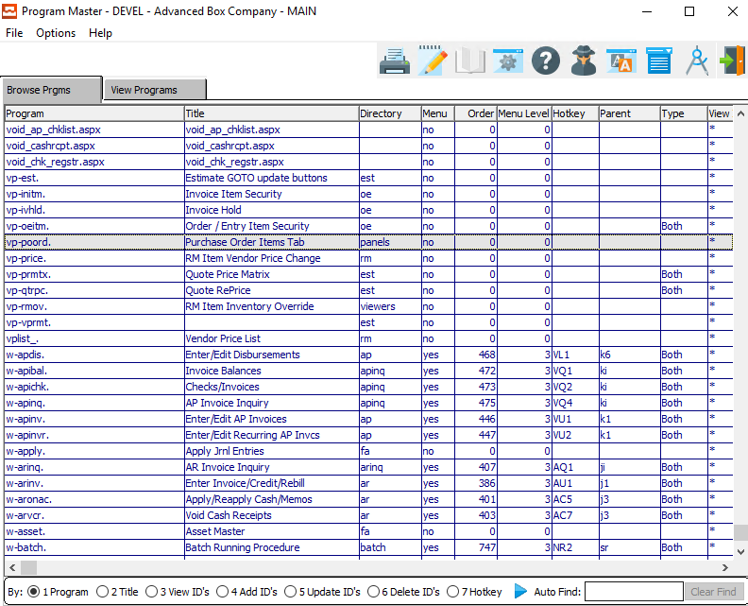

The user can search for their desired program by using the *Auto Find* search box at the bottom of the screen.

Security for individual lines within the *Purchase Order View Tab* can be found within the (vp-poord. ) program. This program specifically grants security access to the individual PO Lines for Purchase Orders. Security for the main information for Purchase Orders uses a different program.

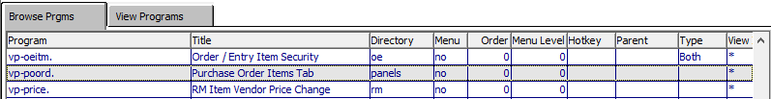

One the system administrator has highlighted their desired program within the list, they may set security by either *User Group* or *User ID* view the *View Programs* tab.

Please Note: *User Groups* are best.

### View Programs

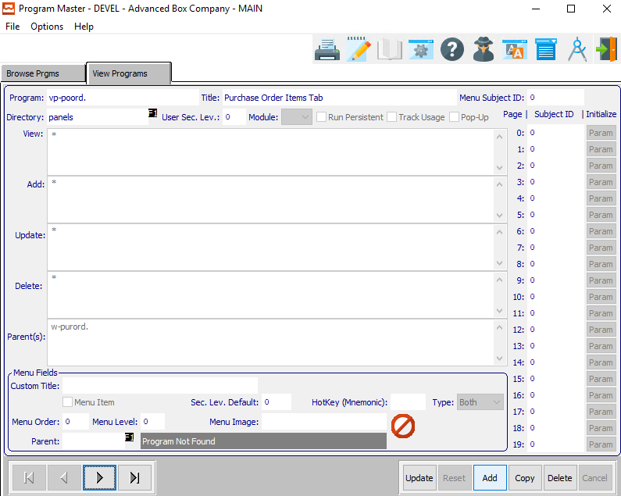

An asterisk (*) within any of these fields means that everyone can access that portion of the program.

#### View ID’s

The *View ID’s* is to set up who can view the data within the currently selected program.

#### Add ID’s

The *Add ID’s* is security for who can add data within the currently selected program.

#### Update ID’s

The *Update ID’s* is security for who can update existing data within the currently selected program.

#### Delete ID’s

The *Delete ID’s* is security for who can delete existing data within the currently selected program.

### User Groups

Under ***“N”-“U”-“5”***, the user can add groups, and assign users to that group. Then, if a user is hired or fired, the system administrator may simply change the users within the group that the employee belongs to. Therefore, no security will need to be changed.

If a user does not have access, the selected button will be grayed out.